Australia’s National
Science Agency
Compiling ecosystem accounts with the synthear R package
  - A summary of functionality and key workflows
Stephen Blair Stewart
29 November 2022

Citation
Stewart SB (2022) Compiling ecosystem accounts with the synthear R package: a summary of functionality and key workflows. CSIRO, Australia.
Copyright
© Commonwealth Scientific and Industrial Research Organisation 20XX. To the extent permitted by law, all rights are reserved and no part of this publication covered by copyright may be reproduced or copied in any form or by any means except with the written permission of CSIRO.
Important disclaimer
CSIRO advises that the information contained in this publication comprises general statements based on scientific research. The reader is advised and needs to be aware that such information may be incomplete or unable to be used in any specific situation. No reliance or actions must therefore be made on that information without seeking prior expert professional, scientific and technical advice. To the extent permitted by law, CSIRO (including its employees and consultants) excludes all liability to any person for any consequences, including but not limited to all losses, damages, costs, expenses and any other compensation, arising directly or indirectly from using this publication (in part or in whole) and any information or material contained in it.
CSIRO is committed to providing web accessible content wherever possible. If you are having difficulties with accessing this document please contact csiro.au/contact.

Contents
1 Background 1
2 Concepts 2
3 Package functionality 3
3.1 Key spatial helper functions 4
3.2 Accounting functions 5
3.3 Time-series summaries 12
References 14

Figures
Figure 1 Types of spatial units used in ecosystem accounting. Reproduced from https://seea.un.org/ecosystem-accounting. 2
Figure 2 Workflow visualisation for the accountExtent function. 5
Figure 3 Workflow visualisation for the accountStock function. 8
Figure 4 Workflow visualisation for the tsExtent function. 12
Figure 5 Workflow visualisation for the tsStockFlow function. 13

Tables
Table 1 List of functions available in the synthear R package. The primary functions used for generating accounts and time-series summaries are bolded. 3

Background
The R package synthear (Stewart, 2022) provides a range of raster-based functions for compiling ecosystem accounts. These functions were developed in response to the need for consistent techniques that can be applied generally across many accounting themes (e.g. ecosystem extent, condition, ecosystem services) to support reproducibility, accessibility, coherence, and auditability.

The synthear package is based on earlier work by Stewart et al. (2020), which used a more precise but more computationally intensive vector-tiling approach. Both approaches were designed to support SEEA Ecosystem Accounting (SEEA EA; https://seea.un.org/ecosystem-accounting).

This document is intended to provide an accessible overview of the package functionality, with a more detailed description of the primary functions (that would not otherwise be possible without interpreting the code). This technical report is written based on the status of synthear as at version 1.2.0, and as a result may not reflect the latest release. Please refer to the latest version of the package vignette for specific technical details.

Concepts
The SEEA EA framework (United Nations, 2021) defines several technical concepts for ecosystem accounting.
Basic Spatial Units (BSUs) are the smallest unit of aggregation that are used to represent ecosystem assets (or other reporting areas) and their attributes (SEEA EA, para. 3.72). BSUs are often represented by a regular grid (e.g. 1 km resolution raster images).
The Ecosystem Accounting Area (EAA) is the geographical territory for which an ecosystem account is compiled (SEEA EA, para. 2.12). The EAA ensures that the various stocks and flows are assessed with a consistent spatial boundary.
Ecosystem types (ET) refer to distinct sets of abiotic and biotic components and their interactions (SEEA EA, para 2.11). Ecosystem accounts are typically reported by ET. In practice, other reporting areas (subdivisions of the EAA) may also be useful to report by, such as geographic boundaries used for national and regional statistics (e.g. Local Government Areas, ABS Statistical Areas).
Ecosystem assets (EA) refer to spatially contiguous blocks of ETs (SEEA EA, para 2.11). In practice, EAs are rarely distinguished from the broader ET.
Each BSU must contain mutually exclusive attributes (e.g. ecosystem types, carbon stocks) and provide exhaustive coverage (i.e. tessellation) of the EAA. The spatial units described above are illustrated in Figure 5.
Figure 1 Types of spatial units used in ecosystem accounting. Reproduced from https://seea.un.org/ecosystem-accounting.

Package functionality
The R package synthear includes over a dozen functions to support the compilation of ecosystem accounts using raster-based methods. These methods are aligned to the key spatial concepts adopted by the SEEA EA. A summary of these functions is provided in Table 1.

Table 1 List of functions available in the synthear R package. The primary functions used for generating accounts and time-series summaries are bolded.
Function name | type | description
accountExtent | Accounting | Generate extent accounts for two extent rasters. An optional change type raster can be used to break the additions and reductions into different categories.
accountStock | Accounting | Generate stock accounts using two stock rasters and two extent rasters. An optional change type raster can be used to break the additions and reductions into different categories.
assignLevels | Helper | This function assigns the same categorical labels to all bands within a SpatRaster. This is done either by providing a valid data.table or data.frame, or by propagating the classes that have been assigned to the first band.
autoProject | Spatial | This function checks for alignment between two images, and reprojects a raster based on the reference image where they do not match. Nearest neighbour or bilinear interpolation is selected depending on the type and pixel scale ratio.
burn2bsu | Spatial | This function burns a vector geometry into a raster image. This is useful for representing socioeconomic reporting units on a regular grid.
calcHeatmap | Spatial | Create a heatmap of raster images where pixel values are greater than 0.
genBSU | Spatial | This function generates a raster of Basic Spatial Units (BSUs) for a boundary at a specified resolution and rounding factor.
getScaleRatio | Spatial | This function calculates the approximate pixel scale ratio for two rasters, regardless of the projection used.
multiclass | Spatial | Reclassify unique combinations of values in a stack of classified rasters.
plotTmap | Mapping | Plot a tmap image using a background polygon (i.e. a landmass), a boundary of interest (e.g. an accounting boundary), and a raster image (e.g. categorical or continuous data).
tsExtent | Time-series | Generates a time-series of extents for a series of categorical rasters.
tsPersistence | Time-series | This function calculates expected biodiversity persistence for a set of cells within an assessment area (i.e. the extent).
tsStockFlow | Time-series | Generates a time-series of zonal statistics. Both the extents (zones) and data (stocks or flows) may vary with time.
zonalGmean | Spatial | This function calculates the geometric mean of a raster by categorical zones using a memory-safe method.
zonalHmean | Spatial | This function calculates the harmonic mean of a raster by categorical zones using a memory-safe method.

This document discusses the key features and workflows used by six of the key functions provided in synthear. Please refer to the package vignette or help documentation for descriptions of each function, their arguments, and worked examples.

Key spatial helper functions

genBSU
The genBSU function provides a reproducible method for generating grids of BSUs for an EAA. Polygon geometries are used to define the minimum extent of the BSU grid. Binary values are assigned to BSUs (i.e. pixels) located within (1) and outside (0) of the EAA. The function arguments allow users to generate BSU grids of varying resolution that share a common extent and can be nested. This behaviour is controlled by the following key arguments:
res: The spatial resolution of the BSU grid. Grid cells will be nested where multiple resolutions have been run and the coarser resolution is a multiple of the finer resolution (e.g. 25m and 100m, 100m and 500m).
factor: Rounding factor that is used to define the final bounding box. This adds a buffer to the minimum extent of the polygon geometry, such that the coordinate dimensions are a multiple of this factor.
Validation rules ensure that the rounding factor is a multiple of the resolution, so that the extent will always be consistent for a given polygon geometry and rounding factor, regardless of the resolution.
The function returns the BSU grid as a raster image.

burn2bsu
The burn2bsu function burns a vector geometry into a raster image. This function is useful for generating extent layers that encode socio-economic boundaries, or other datasets that are available in vector formats. From a SEEA EA perspective, the output classification is analogous to ETs (or individual EAs) that could otherwise be provided with an ecosystem extent classification. It acts as a wrapper around the rasterize function from the R package terra (Hijmans, Bivand, Pebesma, & Sumner, 2022), with some added functionality for convenience. The input vector dataset will be automatically reprojected to the coordinate reference system used by the reference raster grid. Users may also select multiple attributes from the input vector dataset to generate unique ids for composite classifications. These attributes are optionally written to an output csv file alongside the classified raster image.

Accounting functions

accountExtent
The accountExtent function accounts for changes in extent between two categorical raster layers. An optional change type raster can be provided to assign reasons for additions or reductions between each extent layer. A summary of the workflow is illustrated in Figure 2.
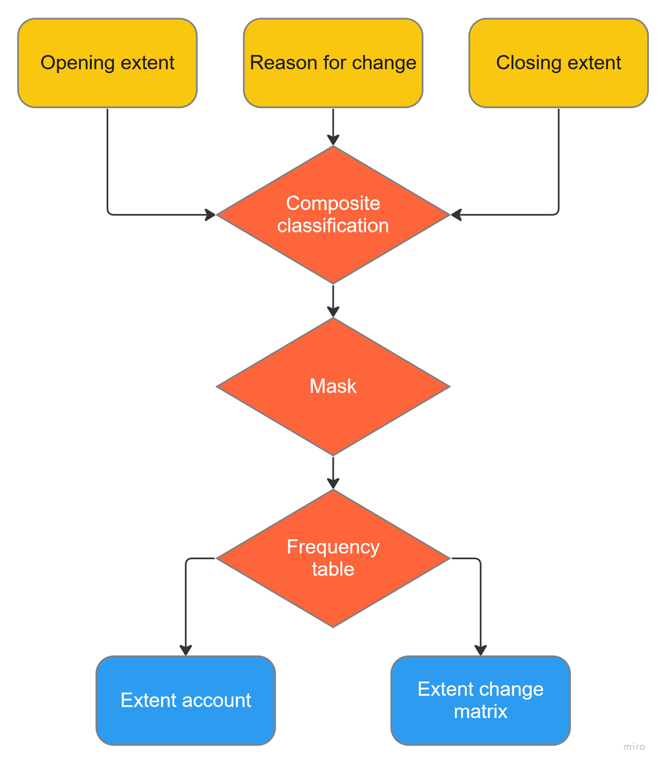
Figure 2 Workflow visualisation for the accountExtent function.

Note that this function currently requires arguments (unitType, unitFactor) for converting BSU counts to areas, and therefore is currently best suited for equal area spatial projections. Notionally, non-equal area projections could be supported at the cost of computation time.

Descriptions of the key processing steps are described below.
Composite classification: This step encodes the opening extent, (optional) reason for change and closing extent into a single raster layer, using the synthear function multiClass.
Mask: This step masks out BSUs (i.e. pixels) located outside of the EAA. The mask will typically correspond to the BSU grid generated using genBSU.
Frequency table: This step counts the frequency of masked values in the composite classification using the terra function freq. Post-processing converts counts into areas, assigns opening and closing extents, and separates additions from reductions (optionally with a reason for change).

The rules for aggregating and post-processing extent accounts are further described as follows. First, the total area of BSUs (E) is calculated using the number of pixels present for each combination of opening extent (t1), closing extent (t2), and reason for change (c):

$$\begin{aligned}E_{t1,t2,c}=\left|{CC}_{t1,t2,c}\right|×F \#\left(1\right)\end{aligned}$$
where:
CC = the composite classification of opening extent, closing extent, and reason for change calculated with multiclass; and,
F = the unitFactor used to convert the pixel area to the unitType.

This provides a data table that can be rapidly processed without the need for additional spatial operations. The opening extent (OE) and closing extent (CE) can be computed for each extent class i by
$$\begin{aligned}{OE}_{i}=\sum{E_{t1=i}} \#\left(2\right)\end{aligned}$$

$$\begin{aligned}{CE}_{i}=\sum{E_{t2=i}} \#\left(3\right)\end{aligned}$$

followed by additions (AE) and reductions (RE) to extent by change type:
$$\begin{aligned}{AE}_{i,c}=\sum{E_{t1≠i, t2=i,c}} \#\left(4\right)\end{aligned}$$

$$\begin{aligned}{RE}_{i,c}=\sum{E_{t1=i, t2≠i,c}} \#\left(5\right)\end{aligned}$$

Finally, the total additions (AE) and reductions (RE) to extent can be calculated as:
$$\begin{aligned}{AE}_{i}=\sum_{c=1}^{\left|c\right|}{{AE}_{i,c}} \#\left(6\right)\end{aligned}$$

$$\begin{aligned}{RE}_{i}=\sum_{c=1}^{\left|c\right|}{{RE}_{i,c}} \#\left(7\right)\end{aligned}$$

The results are written to an Excel file across three tabs:

Extent account: A table with the opening extent, additions, reductions and closing extent for each extent class.
Extent change matrix: A matrix quantifying the opening extent, pairwise transitions between extent classes, and closing extent. This table includes all possible combinations of the union of extent classes present in the opening and closing layers.
Metadata: A table of argument values used and supporting information to aid interpretation of the outputs (e.g. units, scaling factors).

accountStock

The accountStock function accounts for changes in both extent and stock between two pairs of raster layers. An optional change type raster can be provided to assign reasons for additions or reductions between each stock layer. The autoProject function can be enabled to automatically reproject stock raster layers to the same coordinate reference system and grid parameters as the extent raster layers. A summary of the workflow is illustrated in Figure 3.

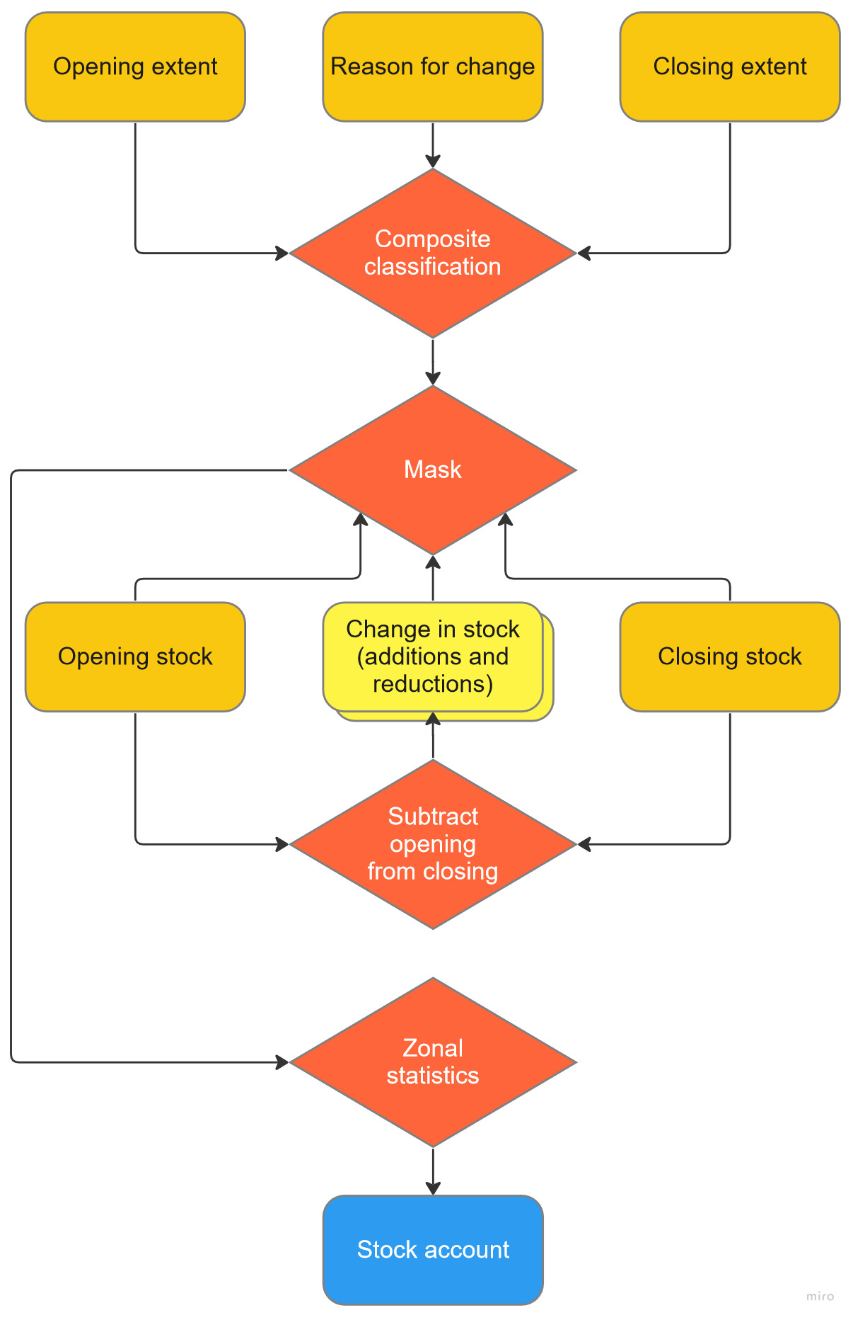
Figure 3 Workflow visualisation for the accountStock function.

Note that this function includes arguments that allow for unit conversions (unitType, unitFactor). In the case of stocks, this can be useful for converting percentages to areas, or to sums from per unit area variables (e.g. tC ha⁻¹ to tCO₂e).

Descriptions of the key processing steps are described below.

Composite classification: This step encodes the opening extent, (optional) reason for change and closing extent into a single raster layer, using the synthear function multiClass.
Subtract opening from closing: This step calculates the difference between the opening and closing stock layers. The change in stock is then separated into one raster layer with only additions (>0) and one with only reductions (<0), so that each can be separately aggregated by sum for each extent class.
Mask: This step masks out BSUs (i.e. pixels) located outside of the EAA. The mask will typically correspond to the BSU grid generated using genBSU.
Zonal statistics: This step calculates the sum of opening stock, changes in stock (both additions and reductions), and closing stock for each of the masked values in the composite classification using the terra function zonal. Post-processing assigns opening and closing stocks and separates additions from reductions (including those due to a reclassification in extent, and optionally with a reason for change).

The rules for aggregating and post-processing stock accounts are further described as follows. The opening stock (OS), closing stock (CS), additions to stock (AS) and reductions to stock (RS) are first calculated for each combination of opening extent (t1), closing extent (t2) and reason for change (c) by

$$\begin{aligned}{OS}_{t1,t2,c}=\sum_{b=1}^{\left|b\right|}{{S1}_{b}}×F \#\left(8\right)\end{aligned}$$

$$\begin{aligned}{CS}_{t1,t2,c}=\sum_{b=1}^{\left|b\right|}{{S2}_{b}}×F \#\left(9\right)\end{aligned}$$

$$\begin{aligned}D=S2-S1 \#\left(10\right)\end{aligned}$$
$$\begin{aligned}{AS}_{t1,t2,c}= \sum_{b=1}^{\left|b\right|}{D_{b}}×F when D_{b}>0\#\left(11\right)\end{aligned}$$

$$\begin{aligned}{RS}_{t1,t2,c}= \sum_{b=1}^{\left|b\right|}{D_{b}}×-F when D_{b}<0\#\#\left(12\right)\end{aligned}$$

where:
S1 = the opening stock raster;
S2 = the closing stock raster;
b = the set of BSUs corresponding to each combination of opening extent (t1), closing extent (t2) and reason for change (c) in the composite classification; and
F = the unitFactor used to convert the pixel area to the unitType.

This provides a series of data tables that can be rapidly processed without the need for additional spatial operations. The opening stock (OS) and closing stock (CS) can be computed for each extent class i by
$$\begin{aligned}{OS}_{i}=\sum{{OS}_{t1=i}}\#\left(13\right)\end{aligned}$$

$$\begin{aligned}{CS}_{i}=\sum{{CS}_{t2=i}}\#\left(14\right)\end{aligned}$$

followed by additions (AS) and reductions (RS) to stock due to both reclassification (rcl) and reasons for change between time periods (c):

$$\begin{aligned}{AS}_{i,rcl}={CS}_{t1≠i,t2=i}- {AS}_{t1≠i,t2=i}\#\left(15\right)\end{aligned}$$

$$\begin{aligned}{AS}_{i,c}={AS}_{t1=i,t2=i}+ {AS}_{t1≠i,t2=i}\#\left(16\right)\end{aligned}$$

$$\begin{aligned}{RS}_{i,rcl}={OS}_{t1=i,t2≠i}- {RS}_{t1=i,t2≠i}\#\left(17\right)\end{aligned}$$

$$\begin{aligned}{RS}_{i,c}={RS}_{t1=i,t2=i}+ {RS}_{t1=i,t2≠i}\#\left(18\right)\end{aligned}$$

Note that this function assumes that reasons for change only apply to the change in stock between time periods, not a change in the underlying extent (a reclassification).
Finally, the total additions and reductions to stock can be calculated as:
$$\begin{aligned}{AS}_{i,total}={AS}_{i,rcl}+\sum_{c=1}^{\left|c\right|}{{AS}_{i,c}}\#\left(19\right)\end{aligned}$$

$$\begin{aligned}{RS}_{i,total}={RS}_{i,rcl}+\sum_{c=1}^{\left|c\right|}{{RS}_{i,c}} \#\left(20\right)\end{aligned}$$

The results are written to an Excel file across two tabs:
Stock account: A table with the opening stock, additions, reductions and closing stock for each extent class.
Metadata: A table of argument values used and supporting information to aid interpretation of the outputs (e.g. units, scaling factors).

Time-series summaries

tsExtent
The tsExtent function generates a time-series of extent areas for a series of categorical rasters. A summary of the workflow is illustrated in Figure 4.
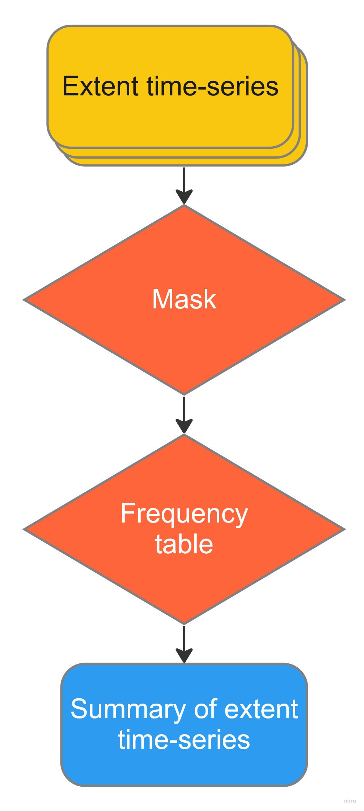
Figure 4 Workflow visualisation for the tsExtent function.

This function reports the total area of extent at each time step and does not currently track additions or reductions. The accountExtent function may be used iteratively for each pair of years in the time-series to track additions and reductions (and optionally the reasons for change) where necessary. Note that this function currently requires arguments (unitType, unitFactor) for converting BSU counts to areas, and therefore is currently best suited for equal area spatial projections. Notionally, non-equal area projections could be supported at the cost of computation time.

Descriptions of the key processing steps are described below.
Mask: This step masks out BSUs (i.e. pixels) located outside of the EAA. The mask will typically correspond to the BSU grid generated using genBSU.
Frequency table: This step counts the frequency of masked values in the composite extent time-series using the terra function freq. Post-processing converts counts into areas.
The results are written to an Excel file across two tabs:
Extent time-series summary: Total area of extent classes for each step in the time-series.
Metadata: A table of argument values used and supporting information to aid interpretation of the outputs (e.g. units, scaling factors).

tsStockFlow
The tstockFlow function generates a time-series of zonal statistics. Both the extents (zones) and data (stocks or flows) may vary with time. This function calculates zonal statistics for each pair of corresponding extent and stock or flow layers in the time series. The total number of extent layers must be either 1, or equal to the number of stock or flow layers. A single extent raster layer may be provided where static boundaries are expected, for example in the case of socio-economic boundaries. The autoProject function can be enabled to automatically reproject stock raster layers to the same coordinate reference system and grid parameters as the extent raster layers A summary of the workflow is illustrated in Figure 5
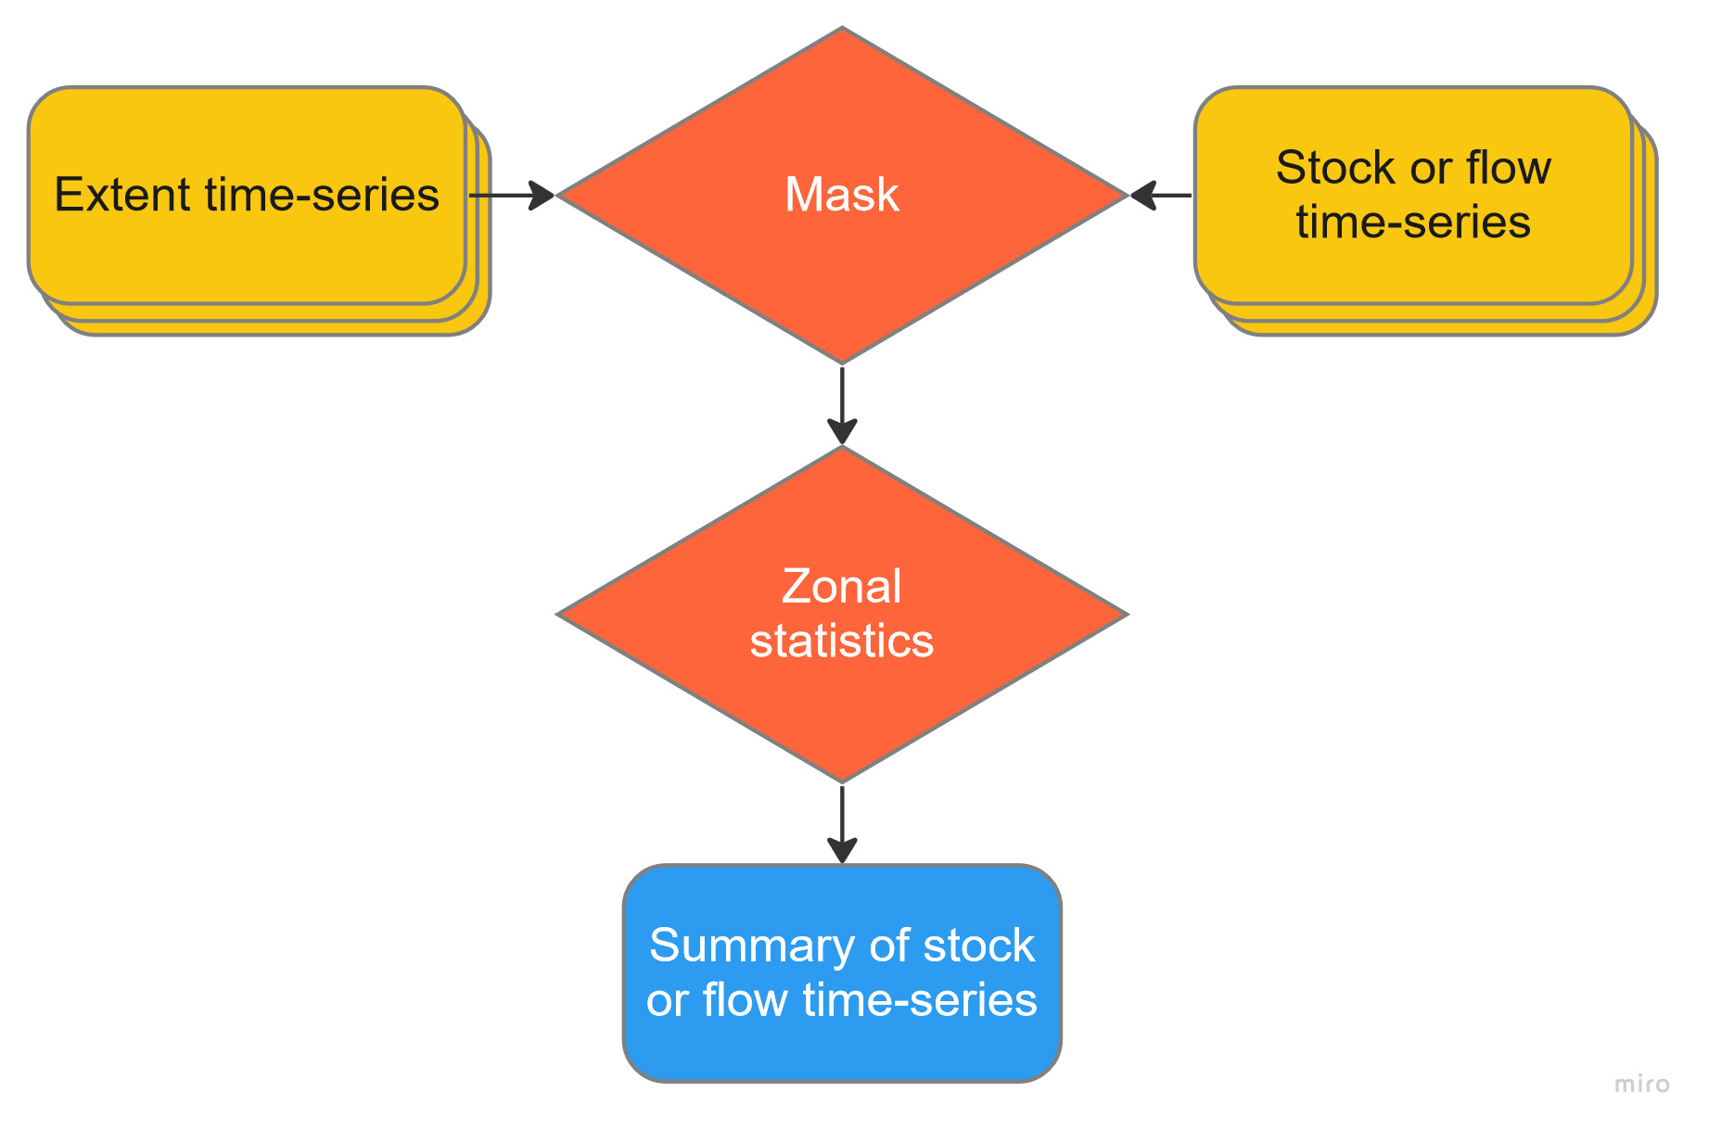
Figure 5 Workflow visualisation for the tsStockFlow function.

This function can be applied to both stocks and flows, and therefore does not track additions or reductions over time. The accountStock function may be used iteratively for each pair of years in the time-series to track additions and reductions (and optionally the reasons for change) where necessary.

Descriptions of the key processing steps are described below.
Mask: This step masks out BSUs (i.e. pixels) located outside of the EAA. The mask will typically correspond to the BSU grid generated using genBSU.
Zonal statistics: This step summarises each stock or flow raster layer by the corresponding extent raster layer. The function currently accepts four different methods of aggregation (mean, sum, harmonic mean, and geometric mean).
The results are written to an Excel file across two tabs:
Stock or flow time-series summary: Summary of stocks or flows for each extent class and step in the time-series.
Metadata: A table of argument values used and supporting information to aid interpretation of the outputs (e.g. units, scaling factors).

References
Hijmans, R. J., Bivand, R., Pebesma, E., & Sumner, M. D. (2022). terra: Spatial Data Analysis (Version 1.6-41). Retrieved from https://CRAN.R-project.org/package=terra
Stewart, S. B. (2022). synthear: Raster-based methods for compiling ecosystem accounts (Version 1.2.0). Retrieved from https://doi.org/10.25919/kx7z-sh64
Stewart, S. B., O'Grady, A., Mount, R., England, J., Opie, K., Roxburgh, S., . . . Smith, G. (2020). Experimental ecosystem accounts for the forestry industry in the Green Triangle: A report from the Lifting farm gate profits-the role of natural capital accounts project. Retrieved from Hobart, Australia: https://publications.csiro.au/publications/publication/PIcsiro:EP205652
United Nations. (2021). System of Environmental-Economic Accounting – Ecosystem Accounting (SEEA EA). Retrieved from https://seea.un.org/ecosystem-accounting

As Australia’s national science agency and innovation catalyst, CSIRO is solving the greatest challenges through innovative science and technology.
CSIRO. Unlocking a better future for everyone.
Contact us
1300 363 400
+61 3 9545 2176
csiro.au/contact
csiro.au
For further information
CSIRO Land & Water
Stephen Blair Stewart
+61 3 6237 5611
stephen.stewart@csiro.au

